DINING OUT: MENUS, CHEFS, RESTAURANTS, HOTELS AND GUIDE BOOKS
Dining out has become a recognized American pastime. But if you can't get to all the restaurants, diners, cafes, tearooms or hotels on your list of places to visit, the “Dining Out: Menus, Chefs, Restaurants, Hotels & Guidebooks” exhibition at the University of Michigan can take you there.
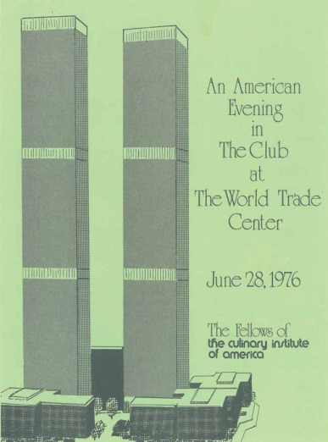
This wide-ranging exhibit, curated by historian Jan Longone, celebrates the history of the eating out experience. The documents on display in the Hatcher Graduate Library have been gleaned from the UM Special Collection Library’s extensive Janice Bluestein Longone Culinary Archive (JBLCA) and includes material from all 50 states and much more. It features such one-of-a-kinds as mid-19th century books about restaurants, chefs, and menus that show offerings of dishes no longer available or popular as well as the latest 21st century menus.
Represented by menus from Alaska to Wyoming, the display runs the gamut from restaurants, diners, drive-ins, carts, lunch rooms, coffee houses, tea rooms, delicatessens, cafes, soda fountains, bistros, cafeterias, trattorias, fast-food, fast-casual, chains, clambakes, barbecues, department stores, dormitories, hospitals, spas, bars, taverns, saloons, and more. And if you dream of travel, there are examples of fine dining on ships and railroad dining cars.
Local cuisines featuring such ingredients as Maine lobster or Louisiana Gumbo are represented along with an intriguing menu from the Leku Ona Basque restaurant in Boise, Idaho, and one from Wall Drug in Wall, South Dakota, with its buffalo hot dogs and Mount Rushmore Red and "Red-Ass Rhubarb” wines.
Among the guidebooks is the rare "Negro Motorist Green Book." At a time when segregation was the norm, the “Green Book” listed accommodations in which African-American travelers would be welcome and safe. Also displayed are guides about where one could eat in ancient Greece and Rome and in modern restaurants covered in Michelin and Zagat guides.
See books about contemporary chefs as well as great chefs of the past - Scappi, Careme, Soyer, Escoffier, Point, and others. Learn how restaurateurs learned to design effective menus and see historic menus of banquets for nobility, popes and kings. Recognize those who spent 50 years conserving Catalan cuisine, and view menus designed by Salvador Dali. See items that contributed to the California Food Revolution, including the original letter from Alice Waters offering a young Jeremiah Tower his job at Chez Panisse in Berkeley. Also on display are iconic menus from New York City and a sampling of Ann Arbor restaurant menus.
“Dining Out: Menus, Chefs, Restaurants, Hotels & Guidebooks,” runs through December 17, 2015, at the Clark Library on the second floor of UM's Hatcher Graduate Library. Join us for a curator talk with Jan Longone on Thursday, November 12 at 4:00 pm in Room 100 (The Gallery) at Hatcher Library. Admission to both is free. Please contact jblong@umich.edu for further information.

